SET 1
CODE:
# MONTHLY SALES DATA VISUALIZATIO
# Install packages (Run only once)
# install.packages("ggplot2")
# install.packages("plotly")
# install.packages("shiny")

library(ggplot2)
library(plotly)
library(shiny)
sales_data <- data.frame(
Month = factor(c("January", "February", "March", "April", "May"),
levels = c("January", "February", "March", "April", "May")),
Sales = c(15000, 18000, 22000, 20000, 23000)
)
print(sales_data)
# TASK 1 - LINE CHART
line_chart <- ggplot(sales_data,
aes(x = Month,
y = Sales,
group = 1)) +
geom_line(color = "blue", linewidth = 1.2) +
geom_point(color = "red", size = 3) +
labs(
title = "Monthly Sales Trend",
x = "Month",
y = "Sales ($)"
) +
theme_minimal()
print(line_chart)
# TASK 2 - BAR CHART
# Sample Product Data
product_data <- data.frame(
Product = c("Laptop",
"Mobile",
"Tablet",
"Headphones",
"Smartwatch"),
Sales = c(45000,
60000,
25000,
18000,
30000)
)
bar_chart <- ggplot(product_data,
aes(x = Product,
y = Sales,
fill = Product)) +
geom_bar(stat = "identity") +
labs(
title = "Top Selling Products",
x = "Products",
y = "Sales ($)"
) +

theme_minimal()
print(bar_chart)
advertising_budget <- c(3000,
3500,
4000,
3800,
4500)

scatter_data <- data.frame(
Advertising = advertising_budget,
Sales = sales_data$Sales
)
scatter_plot <- ggplot(scatter_data,
aes(x = Advertising,
y = Sales)) +

geom_point(size = 4,
color = "darkgreen") +

labs(
title = "Advertising Budget vs Monthly Sales",
x = "Advertising Budget ($)",
y = "Monthly Sales ($)"
) +
theme_minimal()
print(scatter_plot)
# SCATTER PLOT INSIGHTS

cat("\n")
cat("Scatter Plot Insights\n")
cat("----------------------\n")
cat("1. Sales increase as advertising budget increases.\n")
cat("2. Positive relationship exists between advertising and sales.\n")
cat("3. Highest advertising budget corresponds to highest sales.\n")
cat("4. No major outliers are present.\n")
cat("5. Advertising appears to improve sales performance.\n")
# TASK 4 - SHINY DASHBOARD

ui <- fluidPage(

titlePanel("Monthly Sales Dashboard"),
sidebarLayout(
sidebarPanel(
selectInput(
"chart",
"Select Chart",
choices = c("Line Chart",
"Bar Chart")
)
),
mainPanel(
plotlyOutput("plot”

server <- function(input, output) {

output$plot <- renderPlotly({

if(input$chart == "Line Chart"){

p <- ggplot(sales_data,
aes(x = Month,
y = Sales,
group = 1)) +

geom_line(color = "blue",
linewidth = 1.2) +

geom_point(color = "red",
size = 3) +

labs(
title = "Monthly Sales Trend",
x = "Month",
y = "Sales ($)"
) +

theme_minimal()

} else {

p <- ggplot(product_data,
aes(x = Product,
y = Sales,
fill = Product)) +

geom_bar(stat = "identity") +

labs(
title = "Top Selling Products",
x = "Products",
y = "Sales ($)"
) +

theme_minimal()

}

ggplotly(p)

})

Output:

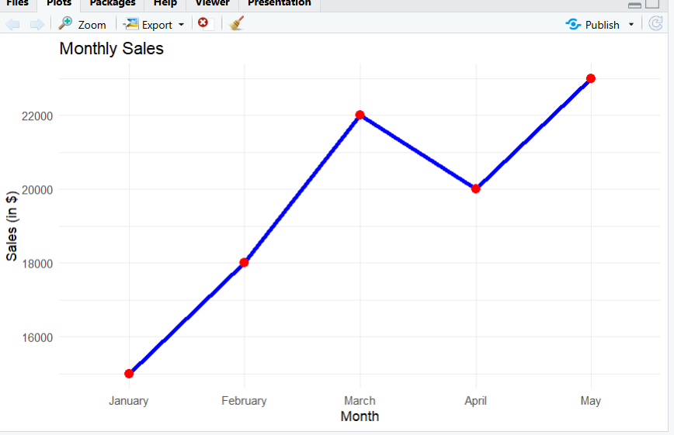

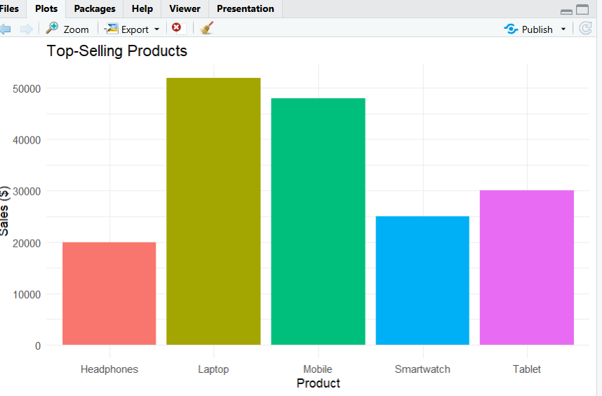
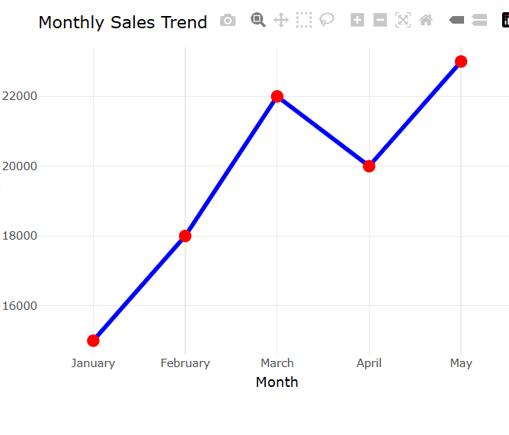
Set 2
Code:
library(ggplot2)

customer_data <- data.frame(
Age = c(25, 30, 35, 28, 40)
)

ggplot(customer_data, aes(x = Age)) +
geom_histogram(binwidth = 2, fill = "skyblue", color = "black") +
labs(
title = "Distribution of Customer Ages",
x = "Customer Age",
y = "Frequency"
) +
theme_minimal()
# Load Libraries
library(ggplot2)
library(dplyr)

# Create Dataset
customer_data <- data.frame(
CustomerID = c(1, 2, 3, 4, 5),
Age = c(25, 30, 35, 28, 40),
SatisfactionScore = c(4, 5, 3, 4, 5)
)

# Count scores and calculate percentages
score_count <- customer_data %>%
count(SatisfactionScore) %>%
mutate(
Percentage = n / sum(n) * 100,
Label = paste0(SatisfactionScore, " (", round(Percentage), "%)")
)

# Pie Chart with Labels
ggplot(score_count, aes(x = "", y = n, fill = Label)) +
geom_bar(stat = "identity", width = 1) +
coord_polar(theta = "y") +
labs(
title = "Distribution of Customer Satisfaction Scores",
fill = "Satisfaction Score"
)
theme_void()
# Load Libraries
library(ggplot2)

# Create Dataset
customer_data <- data.frame(
CustomerID = c(1, 2, 3, 4, 5),
Age = c(25, 30, 35, 28, 40),
SatisfactionScore = c(4, 5, 3, 4, 5)
)

# Create Age Groups
customer_data$AgeGroup <- cut(
customer_data$Age,
breaks = c(20, 30, 40),
labels = c("21-30", "31-40"),
include.lowest = TRUE
)

# Create Stacked Bar Chart
ggplot(customer_data,
aes(x = AgeGroup,
fill = factor(SatisfactionScore))) +
geom_bar() +
labs(
title = "Customer Satisfaction Scores by Age Group",
x = "Age Group",
y = "Number of Customers",
fill = "Satisfaction Score"
) +
theme_minimal()
# Install packages (Run only once)
install.packages("wordcloud")
install.packages("RColorBrewer")

# Load Libraries
library(wordcloud)
library(RColorBrewer)

# Sample Customer Feedback
feedback <- c(
"Excellent service and friendly staff",
"Very satisfied with the product quality",
"Average experience but good support",
"Fast delivery and excellent service",
"Highly satisfied and will recommend"
)

# Combine all feedback into one text
text <- paste(feedback, collapse = " ")

# Convert text to lowercase
text <- tolower(text)

# Split text into individual words
words <- unlist(strsplit(text, "\\W+"))

# Remove empty words
words <- words[words != ""]

# Create word frequency table
freq <- table(words)

# Set seed for reproducible output
set.seed(123)

# Generate Word Cloud
wordcloud(
words = names(freq),
freq = as.numeric(freq),
min.freq = 1,
max.words = 100,
random.order = FALSE,
rot.per = 0.35,
scale = c(4, 1),
colors = brewer.pal(8, "Dark2")
)

# Add Title
title("Word Cloud of Customer Feedback")
library(wordcloud)
library(RColorBrewer)
library(wordcloud)
library(RColorBrewer)
feedback <- c(
"Excellent service and friendly staff",
"Very satisfied with the product quality",
"Average experience but good support",
"Fast delivery and excellent service",
"Highly satisfied and will recommend"
)

text <- paste(feedback, collapse = " ")
words <- unlist(strsplit(tolower(text), "\\W+"))
words <- words[words != ""]
freq <- table(words)

wordcloud(
words = names(freq),
freq = as.numeric(freq),
min.freq = 1,
colors = brewer.pal(8, "Dark2")
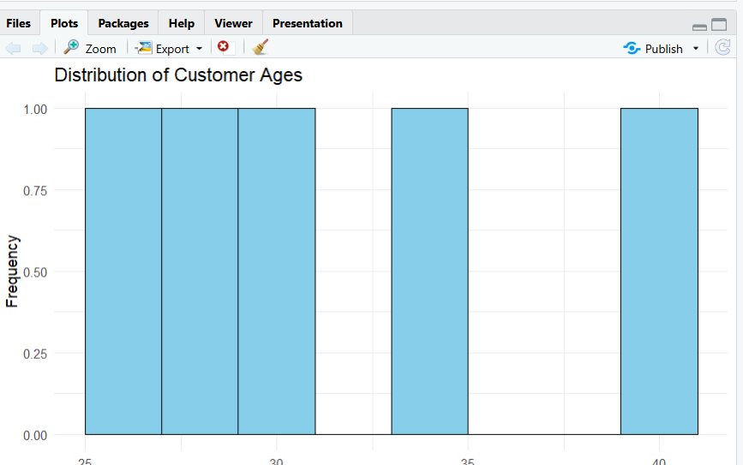
)

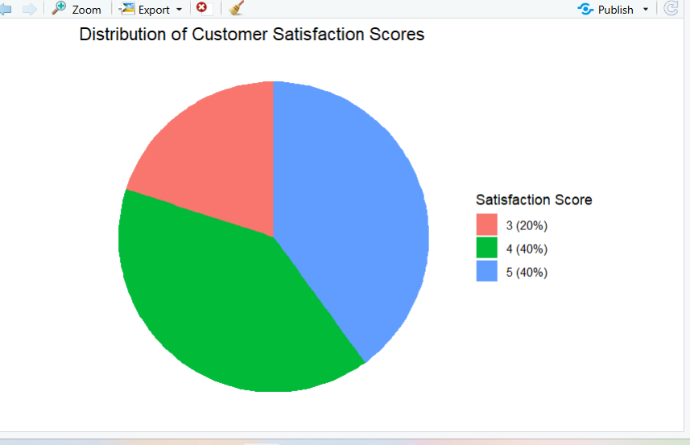
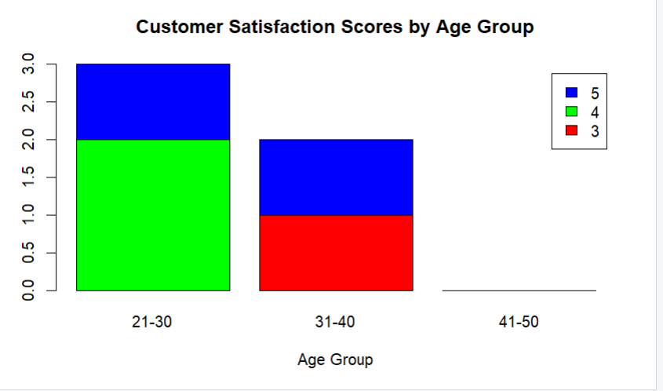

Set 3:
Code:
# Load library
library(ggplot2)

# Create Employee Performance dataset
employee_data <- data.frame(
Employee_ID = c(1, 2, 3, 4, 5),
Department = c("Sales", "HR", "Marketing", "Sales", "HR"),
Years_of_Service = c(5, 3, 7, 4, 2),
Performance_Score = c(85, 92, 78, 90, 76)
)

# Create Line Chart
ggplot(employee_data,
aes(x = Employee_ID,
y = Performance_Score,
color = "Performance Score",
group = 1)) +
geom_line(linewidth = 1.2) +
geom_point(size = 3) +
labs(
title = "Employee Performance Trend",
x = "Employee ID",
y = "Performance Score",
color = "Legend"
) +
theme_minimal()
# Load library
library(ggplot2)

# Create Employee Performance dataset
employee_data <- data.frame(
Employee_ID = c(1, 2, 3, 4, 5),
Department = c("Sales", "HR", "Marketing", "Sales", "HR"),
Years_of_Service = c(5, 3, 7, 4, 2),
Performance_Score = c(85, 92, 78, 90, 76)
)

# Count employees in each department
department_count <- as.data.frame(table(employee_data$Department))
colnames(department_count) <- c("Department", "Employees")

# Create Bar Chart
ggplot(department_count,
aes(x = Department,
y = Employees,
fill = Department)) +
geom_bar(stat = "identity") +
labs(
title = "Distribution of Employees Across Departments",
x = "Department",
y = "Number of Employees",
fill = "Department"
) +
t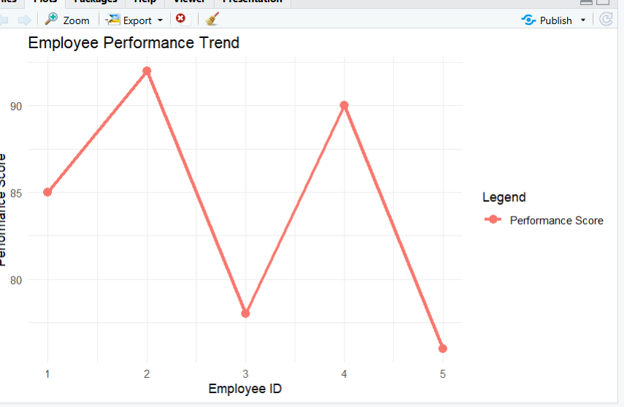

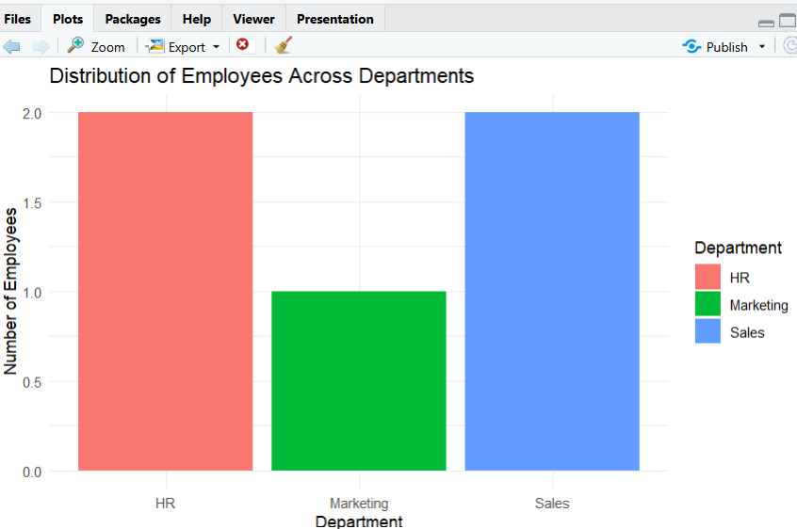

Set 4
Code:
# Load library
library(ggplot2)

# Create Product Inventory dataset
inventory_data <- data.frame(
Product_ID = c(1, 2, 3, 4, 5),
Product_Name = c("Product A", "Product B", "Product C", "Product D", "Product E"),
Quantity_Available = c(250, 175, 300, 200, 220)
)

# Bar Chart
ggplot(inventory_data,
aes(x = Product_Name,
y = Quantity_Available,
fill = Product_Name)) +
geom_bar(stat = "identity") +
labs(
title = "Product Inventory Quantity",
x = "Product Name",
y = "Quantity Available",
fill = "Product"
) +
theme_minimal()
# Load library
library(ggplot2)

# Product Inventory with Categories
inventory_category <- data.frame(
Product_Name = c("Product A","Product B","Product C","Product D","Product E"),
Category = c("Electronics","Electronics","Furniture","Furniture","Stationery"),
Quantity_Available = c(250,175,300,200,220)
)

# Stacked Bar Chart
ggplot(inventory_category,
aes(x = Category,
y = Quantity_Available,
fill = Product_Name)) +
geom_bar(stat = "identity") +
labs(
title = "Quantity of Products by Category",
x = "Product Category",
y = "Quantity Available",
fill = "Product"
) +
theme_minimal()
# Load library
library(ggplot2)

# Product Inventory with Prices
inventory_price <- data.frame(
Product_Name = c("Product A","Product B","Product C","Product D","Product E"),
Product_Price = c(500,350,650,450,550),
Quantity_Available = c(250,175,300,200,220)
)

# Scatter Plot
ggplot(inventory_price,
aes(x = Product_Price,
y = Quantity_Available)) +
geom_point(size = 4, color = "blue") +
geom_smooth(method = "lm",
se = FALSE,
color = "red",
linewidth = 1) +
labs(
title = "Product Price vs Quantity Available",
x = "Product Price",
y = "Quantity Available"
) +
theme_minimal()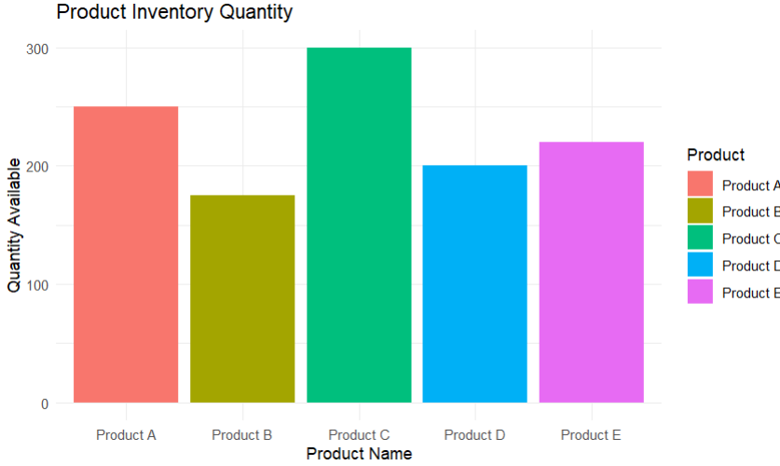

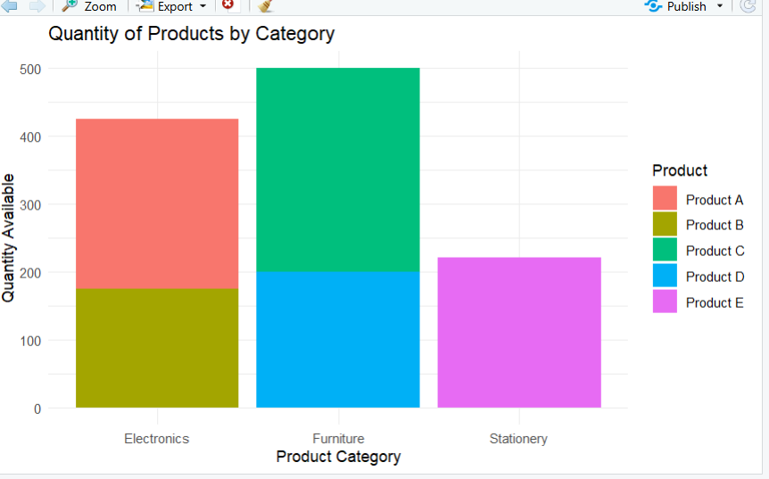
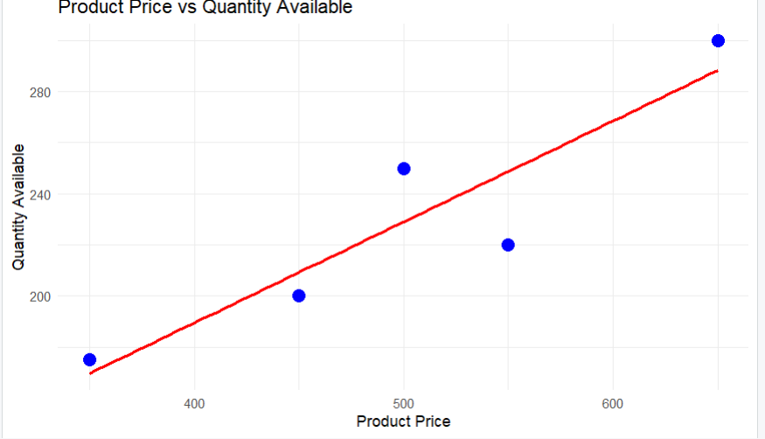
Set 5
Code:
# Load library
library(ggplot2)

# Create Website Traffic dataset
website_data <- data.frame(
Date = as.Date(c("2023-01-01",
"2023-01-02",
"2023-01-03",
"2023-01-04",
"2023-01-05")),
Page_Views = c(1500, 1600, 1400, 1650, 1800),
Click_Through_Rate = c(2.3, 2.7, 2.0, 2.4, 2.6)
)

# Line Chart
ggplot(website_data,
aes(x = Date,
y = Page_Views,
group = 1,
color = "Page Views")) +
geom_line(linewidth = 1.2) +
geom_point(size = 3) +
labs(
title = "Daily Page Views Over Time",
x = "Date",
y = "Page Views",
color = "Legend"
) +
theme_minimal()
# Load library
library(ggplot2)

# Sort data by Click-Through Rate
top_days <- website_data[order(-website_data$Click_Through_Rate), ]

# Select Top 3 Days
top_days <- head(top_days, 3)

# Bar Chart
ggplot(top_days,
aes(x = factor(Date),
y = Click_Through_Rate,
fill = factor(Date))) +
geom_bar(stat = "identity") +
labs(
title = "Top 3 Days with Highest Click-Through Rates",
x = "Date",
y = "Click-Through Rate (%)",
fill = "Date"
) +
theme_minimal()
# Load libraries
library(ggplot2)
library(reshape2)

# Sample interaction data
interaction_data <- data.frame(
Date = as.Date(c("2023-01-01",
"2023-01-02",
"2023-01-03",
"2023-01-04",
"2023-01-05")),
Likes = c(200, 250, 180, 300, 320),
Shares = c(80, 90, 75, 95, 100),
Comments = c(40, 45, 35, 50, 60)
)

# Convert data to long format
interaction_long <- melt(interaction_data, id.vars = "Date")

# Stacked Area Chart
ggplot(interaction_long,
aes(x = Date,
y = value,
fill = variable)) +
geom_area() +
labs(
title = "Distribution of User Interactions",
x = "Date",
y = "Number of Interactions",
fill = "Interaction Type"
) +
theme_minimal()

# Load library
library(ggplot2)

# Create Website Traffic dataset
website_data <- data.frame(
Date = as.Date(c("2023-01-01",
"2023-01-02",
"2023-01-03",
"2023-01-04",
"2023-01-05")),
Page_Views = c(1500, 1600, 1400, 1650, 1800),
Click_Through_Rate = c(2.3, 2.7, 2.0, 2.4, 2.6)
)

# Line Chart
ggplot(website_data,
aes(x = Date,
y = Page_Views,
group = 1,
color = "Page Views")) +
geom_line(linewidth = 1.2) +
geom_point(size = 3) +
labs(
title = "Daily Page Views Over Time",
x = "Date",
y = "Page Views",
color = "Legend"
) +
theme_minimal()
# Load library
library(ggplot2)

# Sort data by Click-Through Rate
top_days <- website_data[order(-website_data$Click_Through_Rate), ]

# Select Top 3 Days
top_days <- head(top_days, 3)

# Bar Chart
ggplot(top_days,
aes(x = factor(Date),
y = Click_Through_Rate,
fill = factor(Date))) +
geom_bar(stat = "identity") +
labs(
title = "Top 3 Days with Highest Click-Through Rates",
x = "Date",
y = "Click-Through Rate (%)",
fill = "Date"
) +
theme_minimal()
# Load libraries
library(ggplot2)
library(reshape2)

# Sample interaction data
interaction_data <- data.frame(
Date = as.Date(c("2023-01-01",
"2023-01-02",
"2023-01-03",
"2023-01-04",
"2023-01-05")),
Likes = c(200, 250, 180, 300, 320),
Shares = c(80, 90, 75, 95, 100),
Comments = c(40, 45, 35, 50, 60)
)

# Convert data to long format
interaction_long <- melt(interaction_data, id.vars = "Date")

# Stacked Area Chart
ggplot(interaction_long,
aes(x = Date,
y = value,
fill = variable)) +
geom_area() +
labs(
title = "Distribution of User Interactions",
x = "Date",
y = "Number of Interactions",
fill = "Interaction Type"
) +
theme_minimal()
